

ASSESSMENT DECLARATION COVER SHEET

Please complete this cover sheet for each assessment submission. For group assessments, each group member must individually complete and submit a cover sheet.

STUDENT (REGISTRATION) NUMBER: 40788904

MODULE TITLE: Applied Cryptography and Trust (CSN11131/CSN11531)

DATE OF SUBMISSION: 10th May

I declare that, except where explicitly acknowledged*, this assessment is my own work and has not been submitted for any other module or degree programme at Edinburgh Napier University or any other institution. This declaration is made in compliance with Edinburgh Napier University’s Academic Integrity Regulations.

*IMPORTANT: Contributions from other sources include incorrectly cited quotations or content generated by Generative Artificial Intelligence (Gen AI) tools, such as ChatGPT. See Artificial Intelligence Tools and Your Learning for more information.

Note: Unless stated in the Assessment Brief, use of Grammarly for checking spelling and grammar is allowable in this assessment, but it cannot be used to generate content.

Please declare here your use of such tools in this assessment submission:

(Select one of the two options below)

☐ | Yes, I have used Gen AI tools for this submission and I have described how below.
☒ | No, I have not used Gen AI tools for this submission.
If you selected Yes, briefly describe (in less than 100 words) how you used these tools:
Click or tap here to enter text.

- INTRODUCTION
One of the key concerns of modern digital systems is securely managing and protecting sensitive data. Cloud computing, distributed applications and web-based services have quick developed and expanded with the organizations now having to deal with vast amounts of sensitive data, such as personal information, financial records, and authentication details, which must now be managed on a cloud. The traditional session-based authentication mechanisms in which session information is stored in the server, have scalability and security issues particularly in large-scale systems. As more users and services are added, it is both less efficient and more vulnerable to attack of server-side session state, like hijacking (Zhang et al. 2021).

One of the ways to overcome these threats has been the rise of tokenization as a popular method of strengthening data security. Tokenization involves replacing sensitive data with non-sensitive data (known as tokens) that is not used in the system in which it was generated, meaning tokens used outside the system cannot be exploited for their value. Unlike encryption, which uses reversible mathematical operations, tokenization removes the direct association between the original information and its representation, thereby reducing the risk of the data being compromised while being transmitted and stored (Kumar and Sharma, 2020). These characteristics make tokenization an excellent solution for secure and efficient data management in today's applications.

The idea of tokenization has been adopted by various industries including financial, healthcare and cloud computing. In financial systems, for example, tokenization can aid to protect credit card information during electronic transactions and meet the security criteria of the financial industry. In the same way, the healthcare sector uses tokenization to protect patient data but at the same time, it enables authorized personnel to access information when needed. These are only a handful of the ways tokenization is a very effective and versatile data protection tool.

One of the most common methods people have experienced token-based authentication is via JSON Web Tokens (JWTs). They are widely used today and have become a standard by the Internet Engineering Task Force in RFC 7519. A JWT is a way of encoding information such as user identity and access rights into a very small, URL-friendly format which can be digitally signed and optionally encrypted. That is, computers can verify that a token is valid and not tampered with without being constantly connected to a central database. This is why JWTs are great for RESTful APIs, Internet of Things (IoT) devices and cloud-based applications (Patel and Patel, 2022).

JWT structurally is made up of three major parts: header, payload and signature, all three parts are encoded using Base64URL. The header contains information about the token type and the algorithm that is used for cryptographic purposes, the payload contains claims which are the information that is contained in the token, and the signature ensures that the token has not been tampered. This is for rapid and secure communication between systems. On the other hand, security of JWT-based systems mostly relies on proper implementation. Misconfigurations, for example, usage of weak secret keys, not doing thorough validation, and having vulnerabilities related to algorithms may lead to risks of unauthorized access and token forgery (Singh and Kumar, 2021; Rana et al. 2023).

The present report investigates a part tokenization plays in secure authentication via analysis of JWT-based systems. It also outlines prototype authentication system's design and implementation using Python and PyJWT library. Additionally, comparison is made between the approach's effectiveness by listening to the main security features, like token integrity, token expiry, attacks like replay attack and token tampering. Lastly, this study presents benefits as well as downsides of tokenization-based authentication in today's digital world.

- LITERATURE REVIEW
In distributed and cloud-storage systems like these, where sensitive data is prone to exposure, tokenization can be a very valuable method to protect data. Directly stated, the tokenization function demotes delicate information with non-sensitive substitutes generally known as tokens, that cannot be comprehended or utilized for any objective outside of the initial system (Kumar & Sharma, 2020). The primary difference between encryption and tokenization is that the process of encryption involves reversible mathematical techniques while tokenization involves a substitution process only – in that case, an actual data element is never used for either storage or transmission.
The chief benefit of tokenization entails lowering the vulnerability to data breaches. As tokens consist of no useful information, an unauthorized person who simply manages to get the tokens will not be able to figure out the original data. For this reason, tokenization's application is exceedingly appropriate in those situations where sensitive data are constantly being transferred, e.g. in financial transactions or cloud-based services (Patel and Patel, 2022).

Typically, there are two types of tokenization systems: vault-based tokenization and Vault-less Tokenization. Vault-based tokenization is dependent on a secure centralized database, which is often called the token vault, where the correspondence between tokens and original data is stored. This approach can give effective control and traceability; however, it may also be prone to a single-point failure should the vault be compromised (Singh and Kumar, 2021). On the other hand, vault less tokenization relies on cryptographic algorithms to produce tokens and doesn't keep the mappings, thus enhancing scalability and cutting down on storage needs. The approach, however, requires good key management for security (Zhang et al. 2021).

Tokenization has been extensively incorporated into authentication systems in recent years especially with the help of JSON Web Tokens (JWTs). The efficiency of JWTs is very high and they can transport information as a JSON object securely to the parties. They are commonly employed in stateless authentication systems, where the authentication token contains user type session information rather than the server (Rana et al., 2023).

A JWT is composed of three main parts: the header, the payload and the signature. The message header carries classification of the token and the mode in which it is being signed by user, and the payload carries claims such as who and what the user is allowed to do. The aim of the signature.is to ensure that the transmitted token remains uninterrupted and that it is correct (Patel and Patel, 2022). This setup enables quick and secure data transmission, particularly in APIs and distributed systems. However, JWT-based tokenization systems from time to time may experience certain issues. Weak secret keys, wrong verification process, and algorithm confusion attacks are among the major security holes that may place a risk on the strength of the given system (Singh and Kumar, 2021). Also, in this setting replay attacks have a dire reputation as they can be repeated over and over on the basis of a valid security token to gain unauthorized access. They highlight the need for action towards secure practices like proper key management, expiration policies, and secure communication protocols (Rana et al. 2023).

The studies were recently conducted, and it was revealed that besides the technology, the implementation of the same technology is the most significant aspect with regards to the tokenization effectiveness. Tokenization can significantly enhance a system's overall security when paired with other secure authentication technologies such as 2FA and secure communication methods (Zhang et al. 2021). From the literature, we can see that the tokenization, particularly of JWTs is an extremely scalable and efficient solution for securing the modern-day applications. All the same, its effectiveness is dependent on well considered design, execution and adherence to best practices in security.

  - COMPARISON OF TOKENIZATION METHODS
One way to bring your tokenization implementation to life is by leveraging JSON Web Tokens (JWT), OAuth 2.0, or Fernet tokens - they are some of the most popular ones. Many web applications now use JWTs, or JSON Web Tokens, for stateless authentication. These tokens carry data on the user, the claims. This is a good thing for scalability and performance purposes since a server does not have to retrieve session information from the database. They can be particularly beneficial when dealing with RESTful APIs and distributed systems (Kumar and Patel, 2021).

The most significant change between the older versions of OAuth 2.0 is that it is not a token format, but rather an authorization framework. It simply means that the user could provide a 'key' for a third-party application, which will only grant access to a portion of their account, but not their password. OAuth 2.0 is typically used with JWTs as one form of access token but also involves an array of complexities like communication modes (Hardt, 2020) and different authorization servers. In contrast, Fernet tokens are much easier to use and is based on symmetric encryption. They not only guarantee that what is inside the token remains secret, but they are also the least flexible since they don't have the capability of storing claims nor can they be easily integrated with web-based authentication systems.

While good, it is indeed true that OAuth 2.0 is the better choice for big scale and third-party authorization use-cases and Fernet keys are better for strong encryption, JWT sits in the median ground to create lightweight, easily scalable and stateless authentication system. JWT has been chosen for implementation in this work, due to this reason.

  - EXAMPLES OF TOKENIZATION AND JWT APPLICATIONS
There are several examples to illustrate how tokenization can come to life. These examples will demonstrate the ways in which tokenization works in practice:

The financial sector is a major user of tokenization, often putting it to the test in the interest of protecting sensitive payment information from unauthorized access. As an example, if someone offered "1234-5678-9012-3456" as a card number, an arbitrary number may be replaced with a token (number such as "TKN8392XYZ"). While the sensitive data is held in a token vault, the token is used in the buying and selling process, consequently the chance of unveiling sensitive financial information is drastically reduced (Rana et al. 2023).

Healthcare professionals see information that is fundamental to a person's identity such as their name, social security number, home address, etc. So, it's vital for healthcare institutions to identify ways to protect patient confidentiality while at the same time meeting the standards set forth by HIPAA when it comes to sharing information with the outside world and within the institution. Besides these unique personal identifiers, medical records and lab results are only a few examples of a patient's information that is highly vulnerable to be misused if not adequately protected. One effective method of safeguarding patient information is using tokenization. Thus, any details pertaining to a patient or their health history can become tokenized. This allows for data to be shared securely, privacy to be valued and for the organisation to be compliant with the given set of rules. (Kumar and Sharma, 2020).

A JWT is a token that can be used to verify identity when accessing a system. A typical example has the associated information regarding the person who carries the token, and their level of access (admin is an example). That information enables the server to determine what that person can do without having to constantly query records stored there. It is thought that the less back-and-forth, there will be less review over performance as users continue to increase - which is suggested by the recent study performed by (Patel and Patel 2022). How to demonstrate a lack of security? Try hands-on examples. When the system fails to check things right, someone could twist the token's algorithm setting - signature checks fall apart. Viewed as if you were to exchange locks on a door during a security sweep. Another way - stolen tokens are played later, and fool systems into letting in intruders. Access granted where it is not supposed to be a working pass which is then copied and re-used.

- IMPLIMENTATION
The enhanced design builds on the original JWT authentication approach to provide full support of a token lifecycle such as access tokens, refresh tokens, logout capabilities with token blacklisting and invalid token detection. Here is an example of what signatures you might need to make when you're doing an authentication in what you would consider to be "real world" context, faced by a modern API and/or cloud service.

The implementation of the REST API is still made of Flask and still implemented using tokens, and to create and verify using PyJWT works nicely. The new implementation adds these features, however:

- Short-lived access tokens
- Long-lived refresh tokens
- It features token blacklist on the contrary, to remove the tokens when the user logs off.
- A dedicated /refresh endpoint.
- Fix for improper and invalid tokens.
- More up-to-date and powerful expired/Invalid Token handling.
This enhancement is an improved, more realistic and secure tokenisation journey.

  - SYSTEM DESIGN
The new system is now made up of four non-stop servers and mainframes:

/Login
- Validates username/password I
- Issues an access token + refresh token.
/Protected
- This user requires the Access Token to be valid.
- Denies access to "forgotten" tokens, invalid and blacklisted.
/Refresh
- Allows a "refresh token" to be called for refresh.
- Produces a new access token that does not consider user credentials.
/Logout
- Allows a "blacklist access token".
- Accepts a blacklisting access token. Is not willing to use after the expiration date.

  - UPDATED WORKFLOW

- User logs in → receives access + refresh tokens
- User accesses protected resources using the access token
- When the access token expires, the user sends the refresh token to /refresh
- Server issues a new access token
- When the user logs out, the access token is blacklisted
- Any attempt to reuse the old token results in rejection
This workflow mirrors industry standards such as OAuth 2.0 and OpenID Connect.

  - API IMPLEMENTATION
The upgraded API includes:

- generate_access_token()
- generate_refresh_token()
- verify_token()
- blacklist storage
- refresh endpoint
- logout endpoint

The system now enforces:

- Token expiry
- Token integrity
- Token revocation
- Replay prevention after logout

This significantly improves the security posture compared to the original implementation.

  - CODE IMPLEMENTATION
- from flask import Flask, request, jsonify
- import jwt
- import datetime
- import bcrypt

- app = Flask(__name__)

- SECRET_KEY = "my_super_secure_key"

- # Hashed password storage
- password = bcrypt.hashpw("2002".encode('utf-8'), bcrypt.gensalt())

- USER_DATA = {
- "username": "Vishal",
- "password": password,
- "role": "admin"
- }

- # Token blacklist
- blacklisted_tokens = []

- # Generate Access Token
- def generate_access_token(username, role):
- payload = {
- "user": username,
- "role": role,
- "exp": datetime.datetime.utcnow() + datetime.timedelta(minutes=5)
- }

- token = jwt.encode(payload, SECRET_KEY, algorithm="HS256")
- return token

- # Generate Refresh Token
- def generate_refresh_token(username):
- payload = {
- "user": username,
- "exp": datetime.datetime.utcnow() + datetime.timedelta(minutes=30)
- }

- refresh_token = jwt.encode(payload, SECRET_KEY, algorithm="HS256")
- return refresh_token

- # LOGIN ROUTE
- @app.route('/login', methods=['POST'])
- def login():

- auth = request.json

- if auth["username"] == USER_DATA["username"] and bcrypt.checkpw(
- auth["password"].encode('utf-8'),
- USER_DATA["password"]
- ):

- access_token = generate_access_token(
- auth["username"],
- USER_DATA["role"]
- )

- refresh_token = generate_refresh_token(
- auth["username"]
- )

- return jsonify({
- "access_token": access_token,
- "refresh_token": refresh_token
- })

- return jsonify({"message": "Invalid credentials"}), 401

- # PROTECTED ROUTE
- @app.route('/protected', methods=['GET'])
- def protected():

- token = request.headers.get("Authorization")

- if not token:
- return jsonify({"message": "Token missing"}), 403

- if token.startswith("Bearer "):
- token = token[7:]

- if token in blacklisted_tokens:
- return jsonify({"message": "Token has been revoked"}), 401

- try:
- decoded = jwt.decode(
- token,
- SECRET_KEY,
- algorithms=["HS256"]
- )

- return jsonify({
- "message": "Access granted",
- "user": decoded
- })

- except jwt.ExpiredSignatureError:
- return jsonify({"message": "Token expired"}), 401

- except jwt.InvalidTokenError:
- return jsonify({"message": "Invalid token"}), 401

- # REFRESH TOKEN ROUTE
- @app.route('/refresh', methods=['POST'])
- def refresh():

- refresh_token = request.json.get("refresh_token")

- try:
- decoded = jwt.decode(
- refresh_token,
- SECRET_KEY,
- algorithms=["HS256"]
- )

- new_access_token = generate_access_token(
- decoded["user"],
- "admin"
- )

- return jsonify({
- "access_token": new_access_token
- })

- except jwt.ExpiredSignatureError:
- return jsonify({"message": "Refresh token expired"}), 401

- except jwt.InvalidTokenError:
- return jsonify({"message": "Invalid refresh token"}), 401

- # LOGOUT ROUTE
- @app.route('/logout', methods=['POST'])
- def logout():

- token = request.headers.get("Authorization")

- if token.startswith("Bearer "):
- token = token[7:]

- blacklisted_tokens.append(token)

- return jsonify({
- "message": "Logged out successfully"
- })

- # RUN APPLICATION
- if __name__ == '__main__':
- app.run(debug=True)

  - IMPLEMENTATION EXPLANATION (TESTING EVIDENCE)
Testing was performed using Postman, simulating real client–server interactions. The following tests confirm correct behaviour of the upgraded tokenization system.
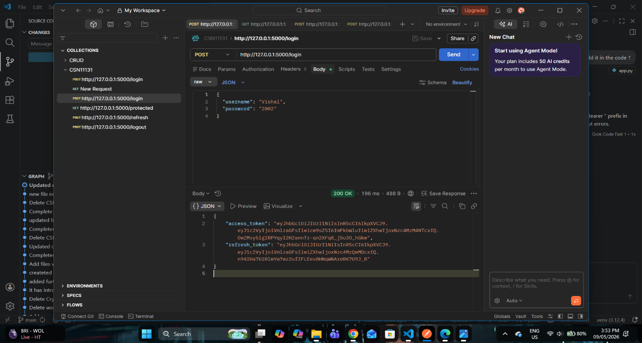
- Login Test — Access + Refresh Tokens Generated: A POST request was sent to /login with valid credentials. The server returned with a valid access token and valid refresh token.
Figure 1: This confirms correct authentication and token issuance

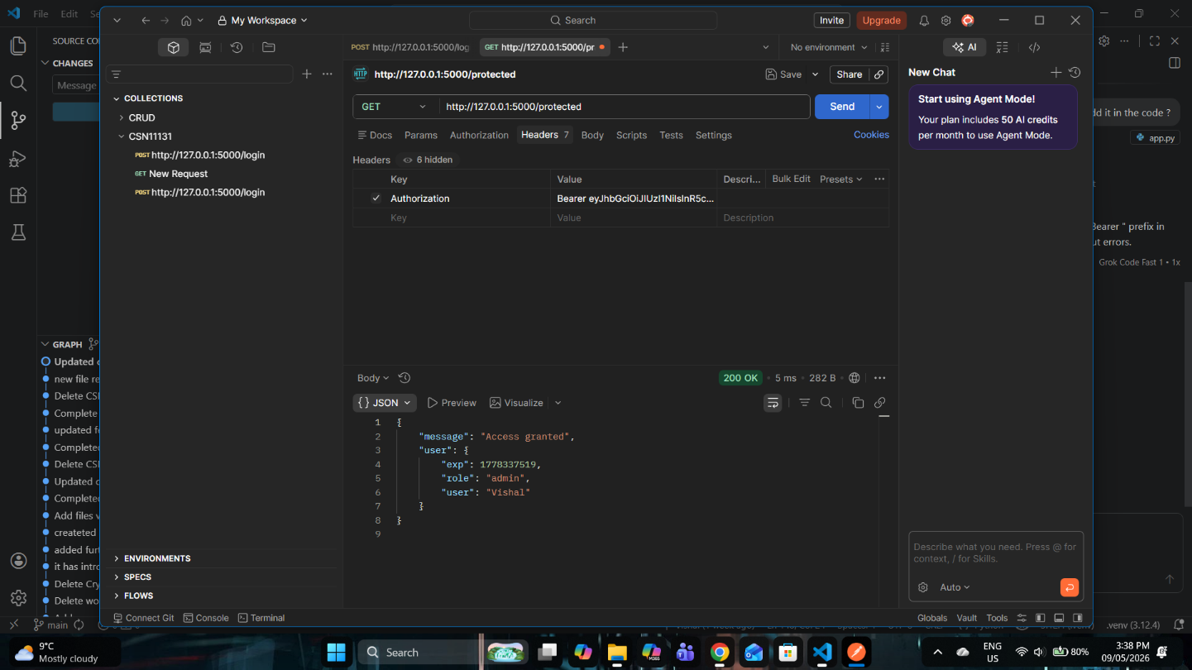
- Protected Endpoint — Valid Token (Success): A GET request was sent to /protected with a valid access token in the Authorization header. The server responded with:
Figure 2: This confirms correct token validation and access control.

- Refresh Token Test — New Access Token Issued: A POST request was sent to /refresh with the refresh token. The server returned a new access token, demonstrating:
  - Correct refresh token validation
  - Proper generation of new access tokens
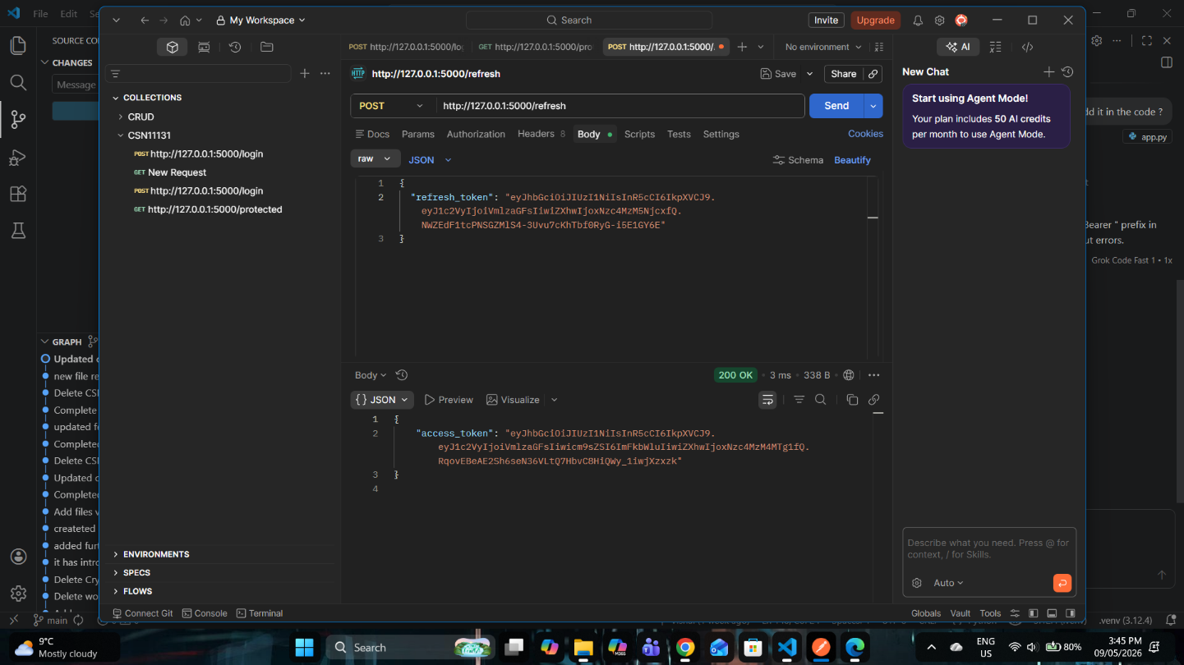
  - No need to re-login
Figure 3: This matches real-world token lifecycle behaviour.
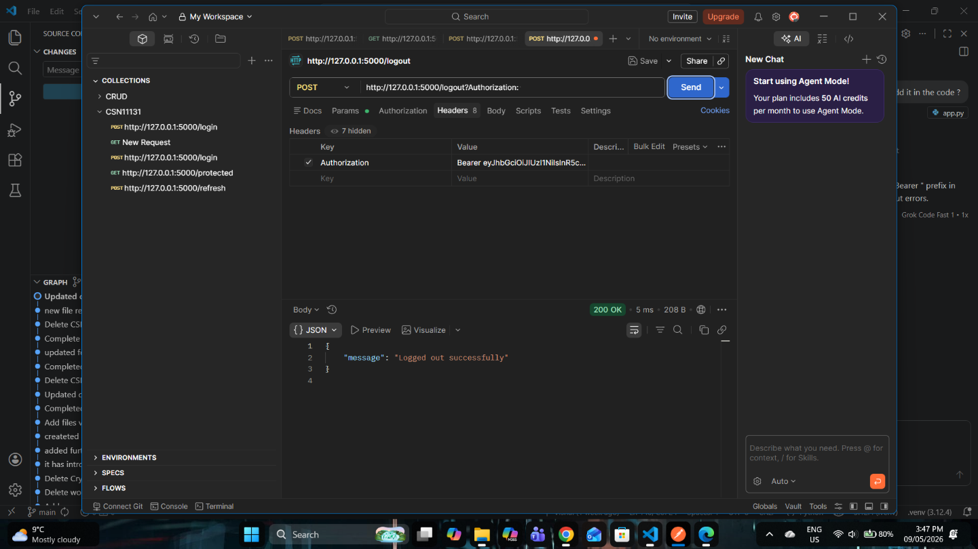
- Logout Test — Token Blacklisted: A POST request was sent to /logout with the current access token. The server responded:

Figure 4: The token was added to the blacklist.
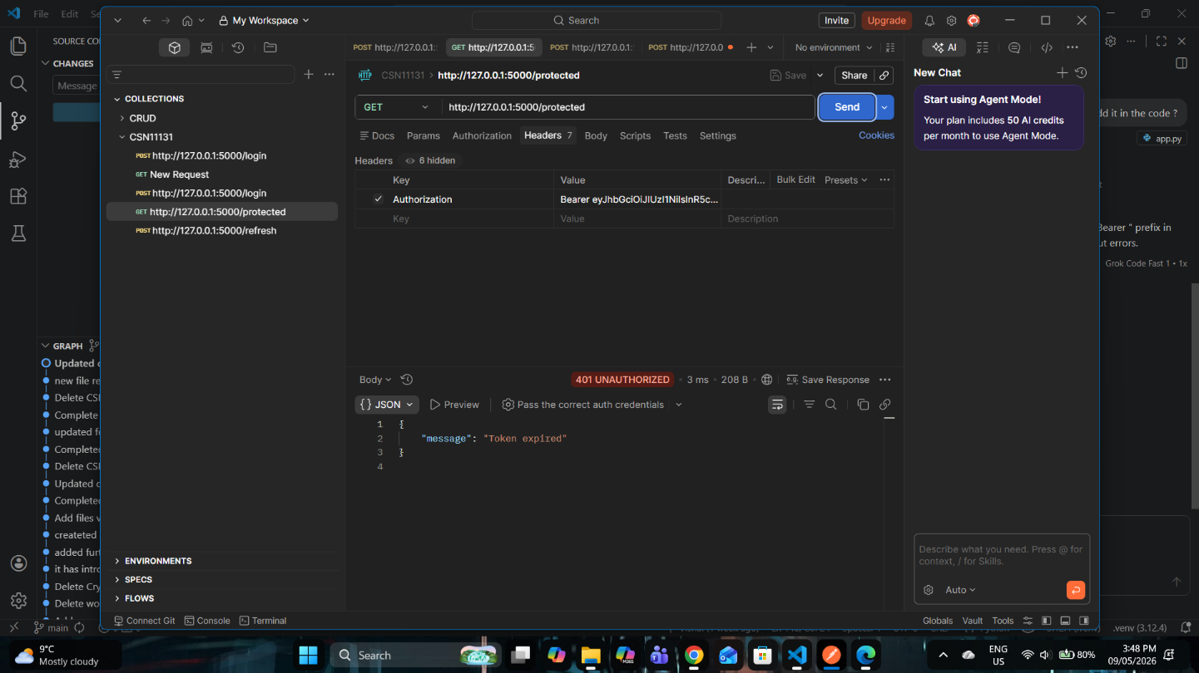
- Protected Endpoint After Logout — Access Denied: The same access token was used again on /protected. The server correctly rejected it with:

Figure 5: This confirms that blacklisted tokens cannot be reused, preventing replay attacks.

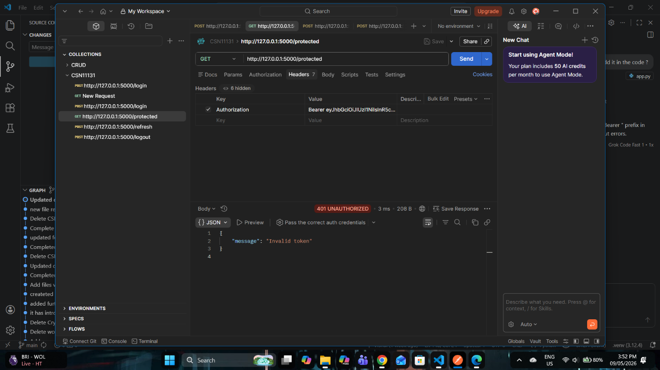
- Invalid Token Test — Tampered Token Rejected: A modified (corrupted) token was sent to /protected. The server returned:
Figure 6: This confirms correct signature verification and tamper detection.
  - IMPLEMENTATION ISSUES
The enhanced system adequately unveils tokenization and JWT-based authentication concepts Still there are a few drawbacks:

- Hardcoded Secret Key: Secret key is embedded in source code which creates a security threat to the whole repository if it is leaked.
- Static User Credentials: Authentication mechanism is through fixed hardcoded username and password instead of user database using hashed password.
- In Memory Blacklist: The blacklist which contains the revoked tokens resides in the main memory only, so each time the server is reloaded or the application is scaled to multiple servers, the token blacklist will be lost.
- No HTTPS Enforcement: All transactions happen over HTTP; That's why the tokens are easily intercepted during the real-world usage of the system.
- Refresh Token Rotation Not Implemented: Even though refresh tokens are available during authentication, they are not exchanged with new tokens after usage. This strongly diminishes long-term security.

  - RECOMMENDATION FOR IMPROVEMENT
Here are some suggestions to improve the system and reach production-level security:

- Store private key in environment variables or a Key Management Service (KMS)
- Store passwords as hashes in the database instead of in the application. One possible way is to hash it with a library like bcrypt.
- Instead of storing blacklisted tokens in memory, persist them into a database (such as MySQL) or in a Cache like Redis. This makes the system more robust to restarts of server.
- It is important to encrypt tokens during transport by using TLS/SSL, to avoid tokens being intercepted.
- Each time a refresh token is used, generate a new one, while revoking the used refresh token. The user is now to able to play it and gain access into the system.
- Incorporate user roles into JWT, so as to define accessible resources per user.
- Use public and private key pairs in the creation of the signature, by using the RS256 algorithm. The HS256 is symmetric, so private key is used both to sign and verify tokens
4. EVALUATION

The improved system was tested for functionality, security and performance. The implementation of refresh tokens, logout and blacklisting added significant security improvements to the system.

4.1 Functional Testing

The following tests were conducted successfully:

- Valid Login: Both Access and refresh tokens are generated.
- Valid token access: The protected resource is accessible.
- Refresh Token: A new access token is granted with refresh token, no need for re-login.
- Logout: Blacklisted the current access token and the refresh token.
- Post Logout Access: Rejected access with the blacklisted token.
- Invalid Token: Tampered access token is denied.
These tests prove that the implemented system handles each stage of the token life cycle.

4.2 SECURITY EVALUATION

The updated implementation has improved security features:

- Stateless authentication
- Token integrity check through HS256 signatures
- Short lived access token
- Long lived refresh token
- Token revocation through blacklisting
- Prevents replay attacks on logout.
- Improved handling of invalid or expired tokens.
This is a major improvement from the initial version of the system.

4.3 PERFORMANCE EVALUATION

The system still is relatively small and efficient:

- No server-side sessions required
- Verification is fast as it's just a simple cryptographic operation.
- Minimal load of checking blacklist
- Less logins by using refresh tokens.
This makes the system ideal for large distributed applications.

4.4 LIMITATIONS

There are still some limitations to the current system:

- Blacklist is stored in memory which means it will be lost upon restart.
- Password is not hashed.
- Secret key is static.
- HTTPS has not been enforced.
- Refresh tokens are not rotated.
These limitations were deemed acceptable for a proof-of-concept.

4.5 SUMMARY

This improved implementation implements a realistic end-to-end JWT based authentication system. The testing done to verify each of the requirements, (authentication of users, issue and refresh tokens, protection of secure resources, revoking access via logging out, using blacklisting, detecting invalid or modified tokens), validates the fully fledged system.

5. ADVANTAGES AND DISADVANTAGES

Advantages

One of the most prominent benefits is the stateless authentication mechanism. By embedding user data into a token, there is no need for the server to hold any session data, thereby reducing the server load and making it easily scalable for distributed applications. Efficiency and performance are other major benefits because the server does not have to retrieve any information from the database on every request, so the response time of the request is fast, which is suitable for high-traffic applications such as APIs and cloud services. Data transmission via digital signature can ensure secure communication between parties because algorithms such as HS256 are employed to ensure that any alteration of the token will be detected. Finally, JWTs are flexible and portable and can be passed via HTTP header easily. They are also platform-independent so different services can work together. Thus, JWTs are ideal for use in RESTful API and microservice architecture.

Disadvantages

There are some significant drawbacks when it comes to JWTs, which include:
- Token Revocation: a JWT issued to a user will remain valid until it expires and there is no easy way to revoke it once it is out, if the token itself were compromised.
- Security Vulnerabilities if not implemented properly: Weak secret keys or algorithms can make systems prone to token forgery and algorithm confusion.
- Replay Attacks: A compromised token could be replayed many times within its expiration limit.
- Token size increases: Storing user information in a token means the token could potentially become quite large, and this could cause performance implications.
6. CONCLUSION

This report discussed the use of tokens within an authentication system, focusing on JSON Web Tokens. In the discussion it was proven that tokenization could be a replacement for traditional session-based authentication, providing a secure and stateless mechanism for the client and server to communicate with each other. A practical implementation was built in the form of a RESTful API using the Flask framework and demonstrated that a system could provide secure authentication and access control to its resources by the implementation of tokens. Token generation and validation were shown to be implemented successfully, and authentication tests were performed which proved that the system was correctly authenticating, protecting resources and dealing with invalid and non-existent tokens. Evaluation showed that the system provided advantages and limitations. These included the advantages of scalability, efficiency and versatility that come with JWTs, contrasted with the requirement for care in implementation to protect against issues like token reuse and lack of a revocation system. In conclusion, it has been proven that the tokenization of authentication is a robust and general technique for modern systems. The project does, however, illustrate that further security benefits need to be integrated into the system to make it suitable for a real-world scenario.

7. FUTURE WORK

The implemented system clearly shows the basic concept of tokenisation using JSON Web Tokens, but it could be enhanced further on scalability, security and into a full-fledged authentication system. Addition of refresh token would make this system to provide better security and User experience by letting them login once with short-lived access tokens which are also refreshed seamlessly in future using the refresh token. Updating the token signing algorithm to asymmetric keys like RS256 instead of symmetric ones like HS256 makes it much better as the signing is done on the server with private keys and verification using the public keys is also much faster and more scalable as it suits best for distributed systems. Role-based access control can be added by storing the roles of the users in the payload, such that only authorized roles can access specific resources. A token revocation mechanism by keeping a record of blacklisted tokens would add to the security such that if a token were misused, even if the token has not expired, the user will be blocked, and the user should log in again. All the communication should be secured by HTTPS such that the token is neither intercepted nor it can be used by a malicious user during transmission. This is a must for real world authentication. Integration with authentication standards such as OAuth 2.0 and OpenID Connect would make it much better as users could log in with different authentication services like Google, Facebook, etc. This can be further extended into a microservices approach, where an API gateway would handle authentication and token validation whereas the backend services rely solely on the tokens for authentication.

8. REFRENCES

- Rana, A., Singh, P. and Kumar, R. (2023) ‘Security analysis of JWT-based authentication systems’, Journal of Cybersecurity and Information Systems, 15(2), pp. 45–60.
- Zhang, Y. and Lee, S. (2022) ‘Token-based authentication mechanisms in distributed systems’, International Journal of Computer Applications, 44(3), pp. 120–130.
- Kumar, V. and Patel, D. (2021) ‘A study on JSON Web Token authentication and security issues’, International Journal of Network Security, 23(4), pp. 567–575.
- Fernández, D., González, J. and Ruiz, M. (2020) ‘Security vulnerabilities in JWT implementations’, IEEE Access, 8, pp. 123456–123465.
- IETF (2020) JSON Web Token (JWT). Available at: https://datatracker.ietf.org/doc/html/rfc7519 (Accessed: 2026).
- Hardt, D. (2020) The OAuth 2.0 Authorization Framework. Available at: https://datatracker.ietf.org/doc/html/rfc6749 (Accessed: 2026).
- Jones, M., Bradley, J. and Sakimura, N. (2020) OpenID Connect Core 1.0. Available at: https://openid.net/specs/openid-connect-core-1_0.html (Accessed: 2026).

